| **REV.** | **Description** | **Date** |
| --- | --- | --- |
| 00 | SPEC ISSUE (NEW MODEL)  Model: ADP-65CG BA | 01/31/2024 |
| 01 | 102A-244210  1. 1.1.1 補充敘述：(Rated voltage is 100-240VAC)  2. 1.1.4 補充敘述：(Rated frequency 50-60Hz) | 04/23/2024 |
| 02 | 102A-247103  1. 修正ITEM 1.2.7 Over Voltage 26.3V to 29.0V。  2. 修正ITEM 1.2.17 Thermal Shutdown。  3. 修正ITEM 2.7 ELECTROSTATIC DISCHARGE (ESD)。 | 07/11/2024 |
|  |  |  |
|  |  |  |
|  |  |  |
|  |  |  |
|  |  |  |
|  |  |  |
|  |  |  |
|  |  |  |
|  |  |  |
|  |  |  |
|  |  |  |
|  |  |  |
|  |  |  |

MODEL LIST: ADP-65CG BA

1. **ELECTRICAL**
   1. **INPUT**
      1. Voltage

The power supply shall be capable of supplying full rated output power over the input range of 90 to 265 VAC RMS. Nominal voltage is 120 VAC (Rated voltage is 100-240VAC) . The power supply shall be capable of start- up (power-on) at 90 VAC and 50 Hz minimum.

* + 1. Power Factor

(For reference only.) The power factor, when measured at 120 VAC and maximum load, shall

be greater than 0.5. The source impedance shall be less than 0.1 ohm.

* + 1. Range Switching

The power supply shall accept the full input range. No range switching is necessary or possible.

* + 1. Frequency

The supply shall operate with an input frequency of 47 – 63 Hz AC.

(Rated frequency 50-60Hz)

* + 1. Current

Maximum steady state input current shall be less than 1.6 Amperes RMS at 90 VAC and maximum load.

* + 1. Input Power Rating

(For reference only) The supply true input power is less than 74 watts.

* + 1. Inrush Current

Maximum inrush current, from power-on (with power on at any point on the AC sinewave) and including but not limited to, three line cycles, shall be limited to a 29% margin of the I2t rating of the input fuse and bridge rectifier:

1.1.6.1 Cold Start

Cool the disconnected power supply long enough to ensure that all components are within 3°C of the minimum temperature as specified in Section 2.1. Apply the maximum input voltage in section

1.1.1 to the power supply.

1.1.6.2 Hot Start

Operate the power supply the maximum ambient operating air temperature as specified in Section

2.1 for 15 minutes. Cycle power to the power supply by removing and reconnecting maximum input voltage as specified in Section 1.1.1.

* + 1. Protection

1.1.7.1 Under Voltage

The power supply shall not be damaged by applying an input voltage below the minimum specified in Section 1.1.1.

1.1.7.2 Catastrophic Failure Protection:

When any single component fails, the power supply will not exhibit any of the following effects:

* + - * 1. Startling noise
        2. Flame
        3. Excessive smoke
        4. Charred PCB
        5. Fused PCB conductor
        6. Dielectric breakdown
        7. Chemical leak outside the case.

1.1.7.3 Power Line Transient

The power supply shall operate within specifications with the transients defined in IEC 61000-4- 4 and IEC 61000-4-5.

The adapter shall survive and the product in which it is installed shall continue to operate with no component failures during and after repeated applications of the following transients. In the event that an end use product is not available for these tests, the power supply shall be loaded at minimum per the load table.

HP recommends that the signal generator be used with low impedance of 12 Ohms.

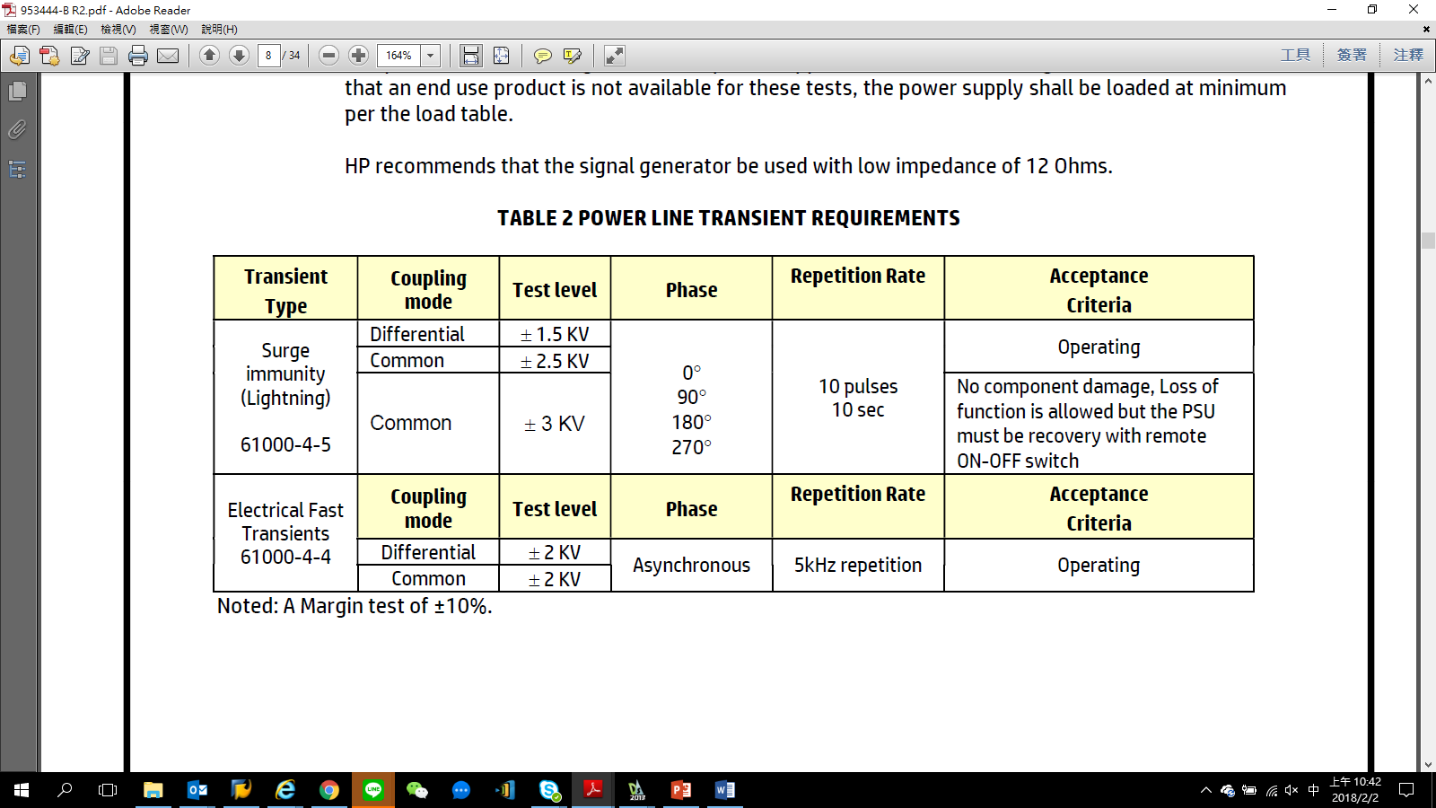**TABLE 2 POWER LINE TRANSIENT REQUIREMENTS**

1.1.7.4 AC Leakage Current:

Class I Equipment

The total combined leakage current when measure in accordance with IEC 60950-1, 2nd Edition shall not exceed 30 microamperes when tested at 250 VAC, 50 Hz in a normal operating condition.

1.1.7.5 Common Mode Noise:

The common mode noise when measure in accordance with IEC 62684 shall not exceed

follow below requirement

* + - * + AC Input Voltage: **90Vac/60Hz & 264Vac/50Hz**
        + The peak-to-peak voltage measured in the frequency range of 10KHz to 400KHz

shall not exceed **150mV peak-to-peak**.

* + - * + Test condition following with Full load (per step) by each 10% load

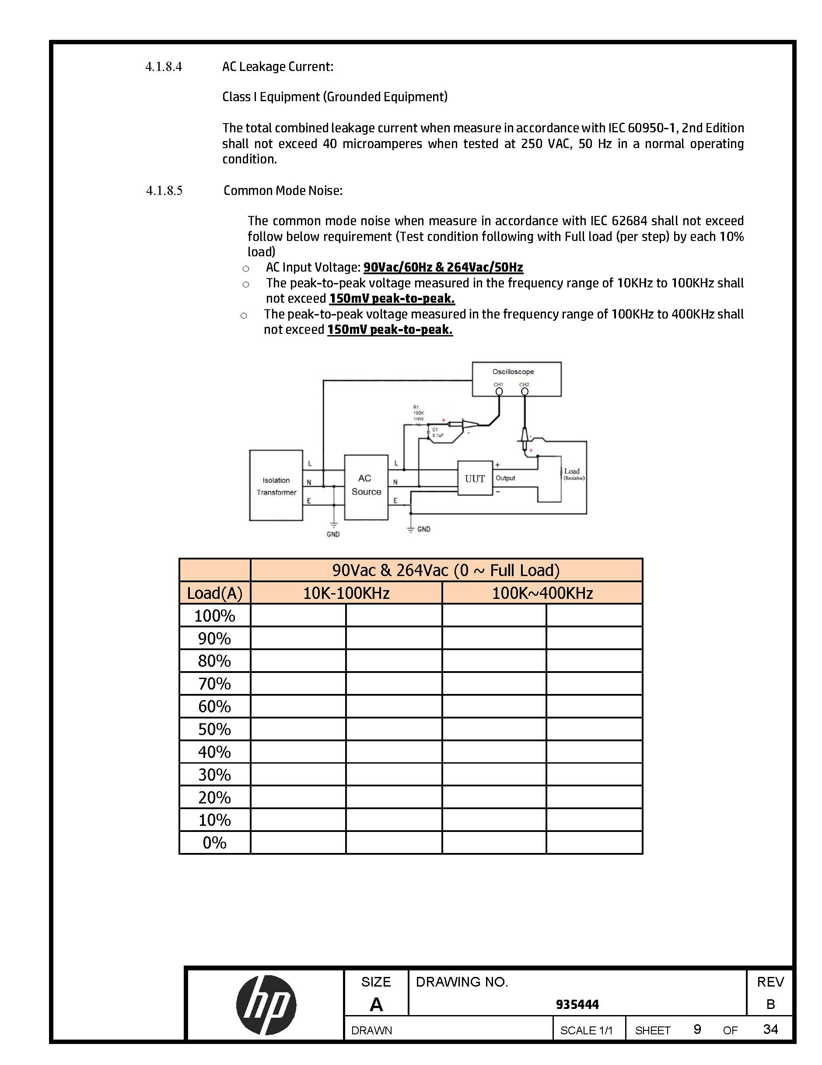

1.1.7.6 Primary to Secondary Ground:

The power supply shall have a 1 Meg Ohm 1/4W resistor and 0.1uF/100V capacitor parallel combination between earth ground (FG) and secondary DC ground.

1.1.7.7 ISN resistors:

The power supply shall have a 470Ohm(minimum) resistor between earth ground(FG) and secondary DC ground.

* + 1. Energy Efficiency

The device shall conform to the EPA Energy Star Requirements Level VII for External Power Supplies:

* + - * This Adaptor shall be designed to meet DOE requirement. Average Efficiency value of 25%,50%, 75% and 100% load condition with 115Vac/230Vac(option) input voltage shall be follow the below table:

|  |  |  |
| --- | --- | --- |
| Output Voltage (V) | Rated Max Output Power (W) | Average Efficiency (%) |
| 5 V | 15W | 81.84% |
| 9 V | 27 W | 87.3% |
| 15 V | 65 W | 89.0% |
| 20 V | 65 W | 89.0% |

**No Load/Light Load**

**Output Load Maximum Input Power 0W 0.070W**

**(5V output)**

**0.15W 0.3W**

**0.5W 1.0W**

**1.0W 1.7W**

**1.5W 2.4W**

1.1.10 BMC EYES DIAGRAM

- Device shall conform to the **BMC EYES DIAGRAM** requirements for as below

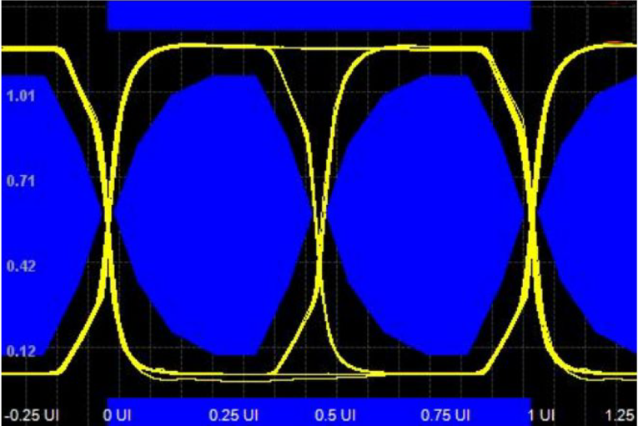

1.1.11 PD3.1 Compliance Test

* + - * : Follow Ellisys to ran compliance testing for PD protocol validation
      * Shall be apply and compliance USB-IF certification
  1. **OUTPUT**
     1. Voltage

Outputs shall be provided as defined and measured at the output connector of the supply:

|  |  |
| --- | --- |
| NOMINAL VOLTAGE (V) | REGULATION |
| 5 V | 4.75 V - 5.25 V |
| 9 V | 8.55 V - 9.45 V |
| 15 V | 14.25 V - 15.75 V |
| 20 V | 19.0 V - 21.0 V |

* + 1. Current

|  |  |  |
| --- | --- | --- |
| NOMINAL VOLTAGE (V) | Load Current (A) | |
| MIN. | MAX. |
| 5 V | 0 A | 3.0 A |
| 9 V | 0 A | 3.0 A |
| 15 V | 0 A | 4.33 A |
| 20 V | 0 A | 3.25 A |

* + 1. Power

The power supply shall be capable of continuously supplying, when installed in the end use system, 65 Watts under all specified conditions.

* + 1. Transient Response

(Step Load) The following transient loads are to be applied to the output. The frequency range of the transient loads described shall be from 1 Hz to 5 kHz. The waveform shall be a square wave with the slope of the rise and fall at 1 A/microsecond. Measurements should be made at output cable connector. External system capacitance 220uF/50V shall be connected to the PSU output.

|  |  |  |  |  |
| --- | --- | --- | --- | --- |
| Test Condition | | | | Regulation |
| AC Input | Nominal Voltage (V) | Load Current (A) | | Design Requirement |
| (VAC) | Minimum | Maximum | (S/R=1A/uS, 1Hz & 5KHz, 50% duty) |
| 90V~264V | +5.0V | 0A | 1.5A | 4.5V – 5.5V |
| 1.5A | 3A |
| 0A | 2.7A |
| +9.0V | 0A | 1.5A | 8.1V - 9.9V |
| 1.5A | 3A |
| 0A | 2.7A |
| +15.0V | 0A | 2.165A | 13.5V - 16.5V |
| 2.165A | 4.33A |
| 0A | 3.897A |
| +20.0V | 0A | 1.625A | 18.0V - 22.0V |
| 1.625A | 3.25A |
| 0A | 2.925A |

* + 1. Output Regulation

At nominal input line voltage (120Vac), the output shall be subjected to the load described in Section 1.2.2, and shall remain within the regulation limits as defined in Section 1.2.1.

* + 1. Protection

The power supply shall automatically shut down under the conditions described below.

* + 1. Over Voltage

The power supply shall provide over voltage protection such that under single component Failure, the output channel volts with a maximum duration of 250millseconds.

|  |  |
| --- | --- |
| NOMINAL OUTPUT | OVER VOLTAGE |
| VOLTAGE (V) | MAXIMUM |
| 5V | 7.25V |
| 9V | 13.05V |
| 15V | 21.75V |
| 20V | 29.0V |

* + 1. Over Current

The power supply shall limit the maximum steady state output current to an average current of 8 Amperes.

|  |  |
| --- | --- |
| OUTPUT VOLTAGE (V) | CURRENT LIMIT (A) |
| 5 V  9 V  15 V  20 V | 115%~125% |

* Fixed Power Source Peak Current Capability
* Shall be meet “01” level.
* 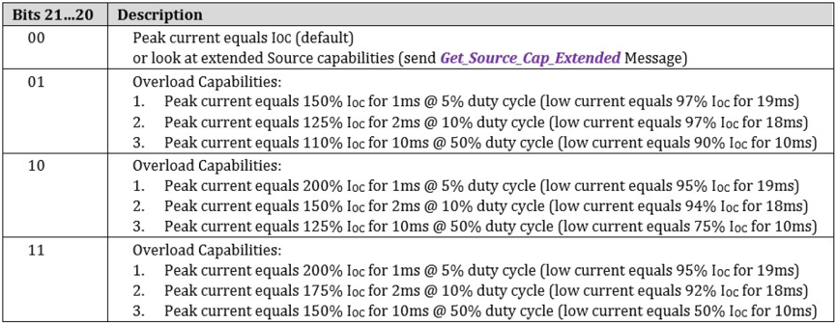
  + 1. Short Circuit

The power supply shall be protected such that a short from output to return shall not result in a fire hazard, shock hazard, or damage to the power supply.

* + 1. Outputs/Ripple/Noise

Maximum allowable peak-to-peak ripple and noise (as measured at the load with 100VAC input) on the output channel shall be 380mVpk-pk (or 250 mV RMS) ripple within 10 kHz to 20 MHz bandwidth. A resistive load (non-electronic) shall be used for this measurement. The output shall be bypassed to return by 1.0 microfarad ceramic capacitor in parallel with 1 0 microfarad tantalum capacitor at the point of load. The load cable shall be the specified output cable assembly. The printed wiring board assembly shall be installed in its enclosure for this measurement or have the measurement leads properly shielded and proper earth grounds applied to power supply. (5V/9V/15V/20V; Maximum Load & Minimum Load.)

* + 1. Stability

The power supply shall be unconditionally stable while operating within its normal operating specification.

* + 1. Overshoot

During power-on or power-off, the output voltage shall be monotonically increasing or decreasing with respect to the overshoot which shall neither exceed below table of volts peak nor be outside the regulation requirements for more than 10 milliseconds (mS).

|  |  |
| --- | --- |
| NOMINAL VOLTAGE (V) | REGULATION |
| 5V | 5.25V |
| 9V | 9.45V |
| 15V | 15.75V |
| 20V | 21.0V |

* + 1. Power-On Time

Output Regulation: Outputs (+5V) shall be in regulation within five (5) seconds after valid input power (90 VAC) has been applied.

* + 1. Rise Time

Output Voltage

* + - * 0V to 5V
      * 5V to 9V
      * 5V to 15V
      * 5V to 20V

The output shall be in regulation within 275mS Maximum. (Measured from 0% to 100% regulation)

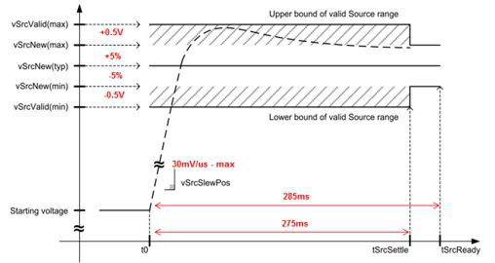

* + 1. Hold Up
       - The power supply output voltage: 5V/9V/15V/20V, shall maintain voltage regulation within the specified limits in paragraph 1.2.1 for at least 5 milliseconds after loss of input voltage measured at 115 VAC and at maximum load.
       - With Host board test turn off time maximum of 500mS.
    2. Acoustic Test

The power supply when tested in an anechoic chamber shall not exceed the sound pressure

levels per the HP AC Adapter Acoustic Noise Test Specification under all output load and ac

input conditions. Acoustic noise measurements shall be conducted in accordance with ISO

7779 (or ECMA-74) and declared in accordance with ISO 9269 (or ECMA-109).

(Follow latest Test Plan)

* + 1. Thermal Shutdown
* The power supply shall incorporate over temperature protection to prevent catastrophic failure from overheating.
* OTP trigger point (before OCP point) following withTS2 requirement of less than 104C.

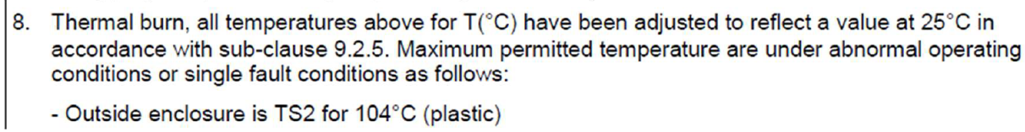

* Thermal throttling function:
* Surface temperature above 85C, output power decrease from 65W to 55W.
* Surface temperature below 75C(78C~72C), output power increase back to 65W.
* Surface temp mitigated below 94C based on thermal throttling or OTP.
* Thermocouples wire type: T-type, 30 AWG
  + 1. LED Indicator

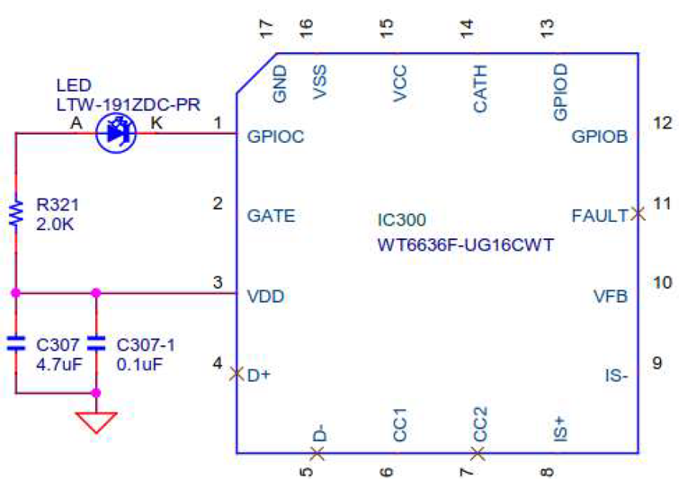

1. **ENVIRONMENTAL REQUIREMENTS**
   1. **TEMPERATURE**
      1. Operating

The supply shall operate from 0 to 35。C. The maximum temperature rise of any surface shall not exceed 45。C when measured at 100Vac and at maximum load.

* + 1. Non-Operating

The power supply can be stored from -20 to 85。C**.**

* 1. **COOLING**

The power supply shall be convection cooled only.

* 1. **HUMIDITY**

The power supply shall withstand without degradation with 95% relative humidity, non-condensing, both operating and non-operating.

* 1. **ALTITUDE**
     1. Operating

The power supply can be operated at 5,000 m above sea level

* + 1. Non-Operating

50,000 feet above sea level.

* 1. **MECHANICAL SHOCK**

(Power supply inside assembly.)

* + 1. Operating

10 G, 11ms, half sine, one shock input in each of three mutually perpendicular axes, for a total of six shock inputs.

* + 1. Non-Operating

100 G peak, trapezoid, 180 in/s velocity change, one shock input per direction in each of three mutually perpendicular axes, for a total of six shock inputs. 240 G peak, 2 ms, half sine, one shock input in each of three mutually perpendicular axes, for a total of six shock inputs.

* + 1. UL Safety

36-inch drop onto hardwood surface, after which no safety hazard is encountered regardless of operational capabilities.

* + 1. Shipping

42-inch drop, all edges, surfaces — while enclosed in appropriate shipping container.

* 1. **VIBRATION**

(Supply inside assembly.)

* + 1. Operating

0.75 G zero to peak, 5 to 500 Hz, 0.5 octaves/minute, one cycle, 5 to 500 to 5 Hz per axis in each of three mutually perpendicular axes.

2.6.2 Non-Operating

1.5 G zero to peak, 5 to 500 Hz, 0.5 octaves/minute, one cycle, 5 to 500 to 5 Hz per axis in each of three mutually perpendicular axes.

0.025 G squared/Hz, 10 to 500 Hz, nominal 3.5 G RMS level, one hour per axis, in each of three mutually perpendicular axes for a total duration of three hours.

* 1. **ELECTROSTATIC DISCHARGE (ESD)**

The AC adapter shall withstand ESD test voltage conditions at any point on the enclosure using the test setups and conditions found in Document 131296 and with transients as defined in IEC 61000- 4-2. As an infrequently user touchable subassembly, the following test levels shall be used:

* + 1. ±15 kV with no abnormal operation, but test to 20kV and report results.
    2. ±15 kV with no damage to power supply, but test to 20kV and report result.

The storage capacitance shall be 150 pF and the discharge resistance shall be 330 ohms.

|  |  |
| --- | --- |
| Mode : | Air Discharge |
| Voltage : | 8KV, 15KV, 20KV |
| Mode : | Contact Discharge |
| Voltage : | 4KV, 8KV |
| Repetition : | Once every 1sec |
| Discharge / test : | 10 |
| Polarity | +/- |

The storage capacitance shall be 150 pF and the discharge resistance shall be 330 ohms.

* 1. **Production Line Hi-pot Test**

One hundred percent (100%) of the AC Adapter shall comply with the minimum Production Line Hi-pot (High Potential) Test as noted below.  The test shall be applied between the PRIMARY (AC LINE and NEUTRAL) to SECONARY (Vo and GND).

|  |  |
| --- | --- |
| **PARAMETERS** | **SETTING** |
| VOLTAGE | 3000Vac Minimum |
| TRIP CURRENT SENSITIVITY | 600 Microamperes Maximum |
| VOLTAGE RAMP TIME | 500 V/Second ramp Minimum |
| DWELL TIME | 1 Second Minimum |
| BREAKDOWN ARC DETECTION | 10 Microseconds Maximum |

note:

The ROD-L DC Hi-pot Tester Model M100DC can be set to comply to the above test parameters.

* 1. **ECO ENVIRONMENTAL**

This section defines environmental requirements that are applicable to all products and product components. Individual components specifications may amend or append requirements to this base set as part of their component-specific requirements, but otherwise these requirements are applicable in all cases.

* + 1. HP GSE

System or component must comply with the latest revision of Hewlett-Packard General Specification for the Environment (GSE) including all subsidiary documents throughout the product life cycle:

* + - 1. HP Standard 011-0 General Specification for the Environment (GSE)
      2. HP Standard 011-1 General Specification for the Environment -- Restricted Materials
      3. HP Standard 011-2 General Specification for the Environment -- Packaging Requirements
      4. HP Standard 011-4 General Specification for the Environment -- Product Requirements
* The current specification and revision history may be accessed through the HP supplier portal. <http://www.hp.com/hpinfo/globalcitizenship/environment/supplychain/gen_specificatio> ns.html
  + 1. Material Restrictions
       1. The material restrictions are defined below. These material restrictions apply to all products, unless specified otherwise by the localized component requirements.
       2. Supplier must provide evidence of removal for all restricted materials. Signed declarations required for each HP part number.
       3. The supplier is required to provide evidence and ability to identify RoHS exemptions accurately.
       4. RoHS signed declarations required for each HP part number
       5. Signed declaration letters required before release of new products
    2. HP RoHS 2
* System or component must comply with the latest RoHS 2 Compliance Specification (Addendum to HP General Specification for the Environment (GSE), Section 3).
* The addendum defines expiration dates for the RoHS exemptions in the HP GSE and additional material restrictions.
* The expiration dates may be updated as regulatory changes occur.
* The sections below define different tier levels for which exemptions must not be used.
* See reference:

<http://www.hp.com/hpinfo/globalcitizenship/environment/pdf/RoHS2Addendum.pdf>

* + - 1. HP RoHS 2

System or components must not utilize any RoHS exemptions set to expire on or before **31 January 2013** and must not utilize the following newly restricted materials listed in the RoHS 2 Compliance Specification (Addendum to HP General Specification for the Environment (GSE), Section 4) in any homogeneous material:

* + - * 1. 1000PPM or less of HBCDD – Hexabromocyclododecane, CAS# 25637-99-4, 3194-55- 6.
        2. 1000PPM or less of DEHP – Bis (2-ethylhexyl) phthalate, CAS# 117-81-7
        3. 1000PPM or less of BBP – Butyl benzyl phthalate, CAS# 85-68-7
        4. 1000PPM or less of DBP – Dibutylphthalate, CAS# 84-74-2
        5. 1000PPM or less of DIBP – Diisobutyl phthalate, CAS# 84-69-5

Supplier to provide assurance of supply, environmental sustainability and technical performance of alternative replacement solutions

* + - 1. BFR/PVC-Free (Option)

1. The product must be BFR/PVC free except DC cable.
2. Please refer to the HP GSE for the definition of the BFR/PVC-free requirement.
3. See reference:

[http://www.hp.com/hpinfo/globalcitizenship/environment/supplychain/gen_specifications.](http://www.hp.com/hpinfo/globalcitizenship/environment/supplychain/gen_specifications)html

1. Supplier must provide evidence of the removal of BFR, CFR and PVC by Ship Release (SR) minus 4 weeks
2. BFR/CFR/PVC-free signed declarations required for each HP part number
3. Supplier to provide assurance of supply, environmental sustainability and technical performance of alternative replacement solutions
   * + 1. Arsenic free

This section has been removed as it is now part of the HP GSE specification.

* + - 1. Antimony Free
         1. Antimony and its compounds must not be used in parts, components, materials or products in concentrations greater than or equal to 0.1% (1000 ppm) by weight. This requirement does not apply to antimony in solders used to complete a viable electrical connection between semiconductor die and carrier within integrated circuit flip chips packages, cords using brominated flame retardants, varistors used for surge suppression/overvoltage protection in power supplies, and glass lenses.
         2. Supplier to provide assurance of supply, environmental sustainability and technical performance of alternative replacement solutions.
      2. Beryllium Free

Please note that this section defines requirements above and beyond what is restricted in the HP GSE

1. Beryllium and its compounds must not be used in parts, components, materials or products in concentrations greater than or equal to 0.1% (1000 ppm) by weight.
2. Supplier to provide assurance of supply, environmental sustainability and technical performance of alternative replacement solutions.
   * + 1. Phthalate Restriction Phase2

Ortho-phthalates listed below are not present in parts, components, materials or products in concentrations greater than or equal to 0.1%(1000ppm)by weight in any homogeneous material. This requirement does not apply to terephthalates, isophthalates and mellitates. This requirement does not apply to PVC used in power cords or external power supplies.

1. Di-n-pentyl phthalate (DnPP), CAS# 131-18-0
2. Di-n-pentyl phthalate (Dn0P), CAS# 117-84-0,84-75-3
3. Diisononyl phthalate (DINP), CAS# 28553-12-0,6815-48-0
4. Diisononyl phthalate (DIDP), CAS# 26761-40-0,68515-49-1
5. Di-n-pentyl phthalate (DnHP), CAS# 84-75-3
   * + 1. Coatings and Skins

System or components must not use paints or coatings on plastic parts >25 grams. In addition System or components must not use skins or films glued on case parts (ex: IMR film, metallic skins, etc)

* + - 1. DOT and DBT free

This section has been removed as it is now part of the HP GSE specification.

* + 1. ECO Certifications
       - The ECO certifications are defined below. These certifications apply to all products, unless specified otherwise by the localized component requirements.
       - Supplier must provide evidence of removal for all restricted materials covered by the certification requirements. Signed declarations required for each HP part number.
       - Completed environmental checklist form for the required ECO Labels showing compliance eight weeks prior to Ship Release (SR)
  1. Country Certifications
     + - 1. **BLUE ANGEL**

System must meet criteria for Blue Angel Environmental Label for Desktop Computers (RAL-UZ 78). Please see reference:

<http://www.blauer-engel.de/en/products_brands/vergabegrundlage.php?id=148>

* + - * 1. **NORDIC SWAN (V5.1)**

System must meet criteria for Nordic Swan for Personal Computers (v5.1). Please see reference: [http://www.svanen.nu/Default.aspx?tabName=CriteriaDetailEng&menuItemID=7056&pgr](http://www.svanen.nu/Default.aspx?tabName=CriteriaDetailEng&amp;menuItemID=7056&amp;pgr)

=48

* + - * 1. **CHINA SEPA**

System must meet the latest revision of the criteria and certification requirements of the China SEPA eco-label.

* + - * 1. **CHINA CECP (APPLY WITH WHOLE SYSTEM LEVEL)**

System must meet the latest criteria, certification and labeling requirements of the China CECP eco-label

Certification has to be obtained by the same party responsible for obtaining China CCC

* + - * 1. **TAIWAN GREEN MARK**

System must meet the latest criteria, certification and labeling requirements of the Taiwan Greenmark eco-label.

* + - * 1. **JAPAN PC GREEN**

System must meet the latest criteria and certification requirements of the Japan PC Green eco-label. Please see reference: <http://www.pc3r.jp/e/greenlabel/>

The VOC emission rate of specific volatile organic compounds must be less than the guideline values on the JEITA guideline (VOC Guidelines for Personal Computers) that is applicable at the time of declaration

* + - * 1. **KOREA KOECO**

System must meet the latest criteria and certification requirements of the Korea KOCE eco-label. Please see reference: <http://www.koeco.or.kr/eng/>

* 1. Energy Star

2.9.4.2.1 **ENERGY STARTM 5.2**

EPS without integral cooling fans shall meet the level V performance requirements under the International Efficiency Marking Protocol and include the level V marking. Additional information on the Marking Protocol is available at [www.energystar.gov/powersupplies.](http://www.energystar.gov/powersupplies)

Single-output EPS without integral cooling fans shall meet level V requirements when tested using the Test Method for Calculating the Energy Efficiency of Single-Voltage External Ac-Dc and Ac-Ac Power Supplies, Aug. 11, 2004.

* 1. EPEAT

System must meet the latest all EPEAT (IEEE 1680-2006) required criteria and the following optional criteria:

Category: 4.1 Reduction/elimination of environmentally sensitive materials (all optional criteria).

Category: 4.3 Design for end of life (all optional criteria).

Category: 4.4 Product longevity/life cycle extension (all optional criteria). Category: 4.8 Packaging:

Sub category: 4.8.2.2: Packaging 90% recyclable and plastics labeled.

Sub Category: 4.8.3.2: Minimum postconsumer content guidelines (>25% post-consumer recycled corrugate cardboard in packaging).

For reference please see: <http://www.epeat.net/> The following deliverables are required: Completed EPEAT checklist

Completed EPEAT plastics material form Completed EPEAT packaging materials form

Completed supplier declarations of conformity (SDoC) supporting compliance with the EPEAT requirements by HP part number.

List of flame retardants used in every plastic component greater than 25 grams in the product and confirmation that they meet the EPEAT requirement 4.1.6.1 and 4.1.6.2 (Blanks available in the EPEAT Plastics Material Form for reporting)

* 1. Future EPEAT Requirement

As of September, 2010, HP estimates that the EPEAT IEEE 1680.1 standard will be refreshed with an effective date of 2013 (possibly earlier). The expectation is that both required and optional points will be significantly revised.

It is expected that the products will be designed to meet all required design criteria and

meet enough optional points to meet the selected EPEAT goal.

* + 1. Environmental Compliance

2.9.5.1 HP Active Verification Material Testing Specification

* + - 1. Manufacturer must comply with the latest revision of HP Active Verification Material Testing Specification A-SP-ELEN876-00-0000. HP Active Verification Process specification includes HP guidance on component sampling and test methods.
      2. Manufacturer must provide assurance and evidence of an Active Verification Process that

meets HP’s specification, including the following.

* + - 1. Independent third-party test results for new components.
      2. A control method of screening incoming production material for RoHS compliance
      3. Sampling plan
      4. Analytical test results of components before assembled into products
      5. Corrective action methodology
      6. HP will screen selected new products for compliance with restricted substance regulations before the release of new products.
      7. HP Active Verification Material Testing Specification is available via the supplier portal at

https://h20168.www2.hp.com/supplierextranet/index.do (Sign in, then select "Specifications, processes, and other documents.” The document is listed on that page under "Other manufacturing requirements.").

* + - 1. Supplier must provide a controlled process document demonstrating compliance with the HP Active Verification specification

2.9.5.2 HP Design for Recyclability

* Products and their packaging must comply with the latest version of HP's Design For Recyclability, Document No. HP-00007-01 and such specification is part of the specifications for the product.
* In addition to the recyclability requirements established in HP's Design for Recyclability the product should meet the following recyclability requirements:
* >= 90% recyclable when measured using HP’s Recyclability Assessment Tool (RAT).
* Only one plastic material type shall be used in each plastic enclosure part >100g.
* Plastic enclosures shall not contain molded-in or glued-on metal unless metal inserts are easy to remove by one person alone with commonly available tool
* All plastic parts >25 g used in product shall be manually separable by one person alone with commonly available tools into recyclable resin streams.
* HP Standard 007-1 Design for Recyclability is available via the portal at https://h20168.www2.hp.com/supplierextranet/index.do (Sign in, then select " HP Standards Documents "
* Completed HP Recyclability Assessment Tool (RAT) spreadsheet eight weeks prior to Ship Release (SR)

2.9.5.3 Identify and List

The supplier must identify and list any parts, components, or materials used on the product in concentrations greater than or equal to the ppm by weight in any homogeneous material denoted below at DVT exit. The expectation is that the supplier will generate and maintain a list of components containing these substances during the life of the product.

1. Polycyclic Aromatic Hydrocarbons (PAH) 0.1% (1000 ppm)
2. Beryllium (Be) 0.0005% (5 ppm) by weight
3. Antimony (Sb) 0.001% (10 ppm) by weight
4. Bismuth (Bi) 0.1% (1000 ppm) by weight
5. Selenium (Se) 0.1% (1000 ppm) by weight
6. Bisphenol A (BPA) 0.1% (1000 ppm) by weight
7. All Phthalates 0.005% (50 ppm) by weight including:
   * Diisodecyl phthalate (DIDP)
   * Diisononyl phthalate (DINP)
   * Di-n-octyl phthalate (DNOP)
   * Diisobutyl phthalate (DIBP)
   * Di-n-pentyl phthalate (DnPP)
   * di-n-hexyl phthalate (DnHP)
   * bis(2-methoxyethyl)phthalate (DMEP)
   * di-n-undecyl phthalate (DUP)

2.9.5.4 Substance Declaration

Supplier to provide assurance and evidence of a maintained data management system to quickly (~1 week) declare the type and quantity of a particular material in the product. Rationale

1. HP’s Request could be related to individual customer requirement for information
2. REACH candidate list substances
3. Future REACH candidate list substances
4. Other substances that are being considered by governments to be banned or tracked.
5. RoHS substances

2.9.5.5 REACH Reporting

1. Supplier to provide assurance and evidence of a maintained data management system to declare the type and quantity of new REACH materials.
2. New REACH substances added each 6 months.
3. Supplier must track REACH candidate list for action without waiting for HP notification.
4. Reporting requires connection to HP Supplier Portal.
5. Report on REACH substances via the HP supplier portal for each HP part number four weeks prior to Ship Release (SR)

2.9.5.6 Material Engineering Expertise

* Supplier to provide evidence of adequate material engineering expertise for the following:
  1. Choosing restricted material replacements with safe non-hazardous substances that

will not be restricted in the near future and minimize need for product transitions

* 1. Specification of correct analytical testing methods
  2. Interpretation of test results from both internal and external testing
  3. Manage internal testing processes
  4. Understand sub tier supplier manufacturing processes and chemicals used
  5. Analyze sub tier suppliers substance declarations
  6. Knowledge of what is and is not in the product
* Supplier to provide evidence and ability to answer chemical process questions about HP products. Examples include:
  1. Type of chemical process used for corrosion resistance i.e. metal finishes
  2. Knowledge of where certain chemicals could be introduced into products as a contaminant

2.9.6 Other ECO Requirements

2.9.6.1 Energy Requirements

# KOREA E-STANDBY (ENERGY BOY) (IF APPLICABLE)

System must com ply with Korea e-Standby Power Program Regulation on Standby Power Reduction. The detailed requirements can be found in the HP GSE - Product Requirements.

Please note since this requirement is now mandatory by the HP GSE, it will be deleted in future releases of the product specification

# KOREA EPS-MEPS

The External power supply must comply with the Korea **M**andatory **E**nergy **P**erformance **S**pecification (MEPS). The detailed requirements can be found in the HP GSE - Product Requirements.

Please note since this requirement is now mandatory by the HP GSE, it will be deleted in future releases of the product specification.

# AUSTRALIA AND NEW ZEALAND EPS REGISTRATION

The External power supply must be registered in Australia and New Zealand.

The detailed requirements can be found in the HP GSE - Product Requirements.

As of March 2011, annual update is required to confirm the availability of the External Power supply on the market. The EPS need to be active for five years after power supply ODM stops providing the power supply to HP or its partners for final product assembly or as a spare part. This update will be reflected in the next release of the HP GSE.

# FEMP – US

The system must comply with the **F**ederal **E**nergy **M**anagement **P**rogram (FEMP) requirements. Pleas e see reference: <http://www1.eere.energy.gov/femp/technologies/eep_computer.html>

2.9.7 Accessibility

2.9.7.1. **SECTION 508 ACCESSIBILITY – US**

The system must comply with the section 508 Accessibility – US requirements. Please reference: [http://www.section508.gov/index.cfm?FuseAction=content&ID=12](http://www.section508.gov/index.cfm?FuseAction=content&amp;ID=12)

2.9.7.2 EU Energy Related Products (formerly EuP)

# **EUP LOT 6 TIER 1**

* + - * System must comply with the January 7 2010 limits (1 W) for off and standby power consumption. The detailed requirements can be found in the HP GSE - Product Requirements
      * Test results should be provided on HP EL-EN891-02 (Energy Using Products – Standby and off mode energy efficiency test report)
      * Please note since this requirement is now mandatory by the HP GSE, it will be deleted in future releases of the product specification.

# **EUP LOT 6 TIER 2**

* + - * System must comply with the Jan 2013 limits (0.5W) for off and standby power consumption. The detailed requirements can be found in the HP GSE - Product Requirements.
      * Test results should be provided on HP EL-EN891-02 (Energy Using Products – Standby and off mode energy efficiency test report)

# **EUP LOT 7 TIER 1**

* + - * System must comply with the Energy Using Products (EuP) External Power Supply Energy Specifications. The detailed requirements can be found in the HP GSE - Product Requirements
      * Please note since this requirement is now mandatory by the HP GSE, it will be deleted in future releases of the product specification.

# **EUP LOT 7 TIER 2**

System must comply with the April 27 2011 limits Tier 2 of the Energy Using Products (EuP) External Power Supply Energy Specifications. The detailed requirements can be found in the HP GSE - Product Requirements.

# **EUP LOT 3**

System must comply with the following EuP Lot 3 requirement which is currently in draft form:

Requires high efficiency power supply, common requirement with Energy Star v5.2

Sets power consumption limits and product categories similar to Energy Star v5.2 with the following changes:

Provides additional power allowances for TV tuner and Audio cards

Adds new graphic card categorization and power adder limits

Adds limits for Off, and Sleep

Off is covered by EUP Lot 6 Tier2 with the new EUP Lot 3 WOL adder of 1.7W

he 4W Sleep limit is covered by the Korea eStandby requirement

Sets new power transition requirement on S3 to drop to a lower power state (complying with the Off Limits) after 4 hrs of elapsed user inactivity

* + 1. Plastic Markings
       - Plastic parts must be marked according to the requirement listed in the HP GSE. HP 5951-1741-1 specification.
       - Please note since this requirement is now mandatory by the HP GSE, it will be deleted in future releases of the product specification.
    2. Canada EPS certification and Registration

External power supplies must comply with the Canadian standard CSA-C381.1-08: Test method for calculating the energy efficiency of single-voltage external ac-dc and ac-ac power supplies. The EPS must be certified by an accredited body and registered with the Canadian government by the supplier.

Deliverables:

* + - * A signed report and certificate issued by an ISO/EN 17025 accredited laboratory showing compliance with this requirement.
      * Confirmation of registration with the applicable Canadian government agency.
    1. Mexico Sustainable Energy Use Law

External power supplies must comply with the Mexico Sustainable Energy Use Law. Products must be tested for OFF mode at 127V/60Hz and labeled with the power consumption as required.

Deliverables:

* + - * A completed and signed HP Mexico Energy Use Law Report issued by the supplier or by an ISO/EN 17025 accredited laboratory showing compliance with this requirement.
      * Completed HP Registration Form.

1. **AGENCY APPROVALS**

This product shall comply with all Regulatory requirements set forth in Hewlett Packard Specification 481605.

1. **RELIABILITY**

LIFE EXPECTANCY: The power supply shall have a field failure rate of less than 0.1% annually within the first three years of operation.

* 1. De-rating Guidelines

The following component de-rating requirements shall be followed:

* + - * Semiconductor junction temperature shall be less than 130。C.
      * Thermal De-rating at normal operation shall be <90%. Thermal measurements will be verified with the power supply mounted in a representative product enclosure. OTP shall not result in any damage and safety or reliability degradation. Need to meet HP
      * Life time requirement is any load, Voltage and ambient temperature.
      * Resistor power de-rating will be consistent with the resistor type and application
      * Component voltage de-rating shall be < 95% for all continuous conditions.
      * Components shall not exceed 100% of their voltage rating during start-up and transients; exception: Bulk Capacitors shall not exceed 110% during transients.
      * Component current de-rating shall be <90% for all continuous conditions. Exception: Bulk Capacitors shall not exceed 100% for all continuous conditions. The effects of
      * ripple current heating shall be accounted for in this de-rating.
      * All components shall be de-rated to insure meeting the calculated MTBF
      * All magnetic devices shall be rated for 130。C minimum
      * All capacitors must be rated at 2000 hours or greater at maximum rated temperature, unless otherwise approved by HP. In any load, voltage and temperature, all capacitor must meet HP lifetime define
  1. E-Caps life time
     + - All Aluminum electrolytic capacitors shall have a minimum lifetime of 8,736 hours at ambient temperature of 35degC and 80% load.
       - Usage profile 8h x 52 weeks x 3 yrs = 8,736 hours
  2. E-Caps Charge / discharge cycles

If the design presents operational modes where sustained regular repetitive heavy E-cap charge

/ discharge cycles are used, the supplier has to ensure that the E-caps are suitable for such use and that these charge / discharge cycles are within the components specification limits.

* 1. Critical Components

The critical components list defines components with critical functionality, specifications, attributes, and parameters essential to the proper operation of the power supply and completed system. Once the list is complete for production, any deviation from this list requires documented completion of an agreed upon test plan. Final approval requires written HP acknowledgment. Due to the critical nature of these components, any deviation from the agreed upon BOM/AVL will jeopardize the stability, robustness and/or operation of the board. The timeframe for AVL proposals and finalization is described in the appropriate Statement of Work and schedule milestones. Specific application criteria for critical components are defined in Table 3.

**TABLE 3**

**EPS CRITICAL COMPONENTS CRITERIA**

|  |  |  |
| --- | --- | --- |
| **Part Description** | **Application** | **Notes** |
| Bridge Diodes | AC rectification | 800V breakdown voltage minimum |
| Capacitors | Frequency and loop compensation | X7R dielectric or better |
| Capacitors | High voltage primary snubber circuits | Y5S or better |
| Capacitors | LLC resonant capacitor | PP (polypropylene) material or better |
| Capacitors(Plastic CAP) | PFC and LLC circuit | MPP or MPE is recommended. The PE type is restricted. |
| Bulk capacitor | Dc-bus | Active PFC, Boost, Fly-back topologies bulk cap rating shall be 450Vdc / 105degC minimum. (Optional) (Keep layout location) |
| FET | DC to DC main switching, active PFC and stby circuit FET | FETs should be rated at least   * 600V Active PFC MosFET * 650V PWM MosFET for Fly-back topologies * 600V MosFET for LLC topologies |
| MOV (Metal Oxide Varistors) | EMI-filter, DC bus | If the usage of MOVs can’t be avoided their voltage rating has to be greater 385Vrms |
| Adhesive | Component anchoring | Must be Electronics Grade and meet UL94V-0 |
| Glue | Component anchoring | AB Glue is not allowed (fix component, thermal glue…) |
| Red Phosphorus | Material | Red Phosphorus must not be used as flame retardant in any part of the power supply especially AC inlet and DC cable / plug. |
| AC fly leads / wire | AC socket | Must to use fly leads / wire to solder AC inlet to PCB. |

**5. MECHANICAL**

|  |  |  |  |  |  |  |  |  |
| --- | --- | --- | --- | --- | --- | --- | --- | --- |
|  | Item | Conditions | | | | | Specification | |
| 1. | Bending test | Bead core - DC cord | | | | |  | |
| Load | Angle (θ) | Arbitrary  direction | Cycles in every  minute | Sample size |
| 200 g | ±90° | 5000 Cycle | 40 Cycles | 5 Pcs | Disconnection rate of the wire shall be 30% or less, without damage to the insulations, etc.. | |
| DC plug over mold | | | | |  | |
| Load | Angle (θ) | Arbitrary  direction | Cycles in every  minute | Sample size |
| 200 g | ±180° | 1000 Cycle | 40 Cycles | 5 Pcs | Disconnection rate of the wire shall be 10% or less, without damage to the insulations, etc.. | |
| 200 g | ±180° | 5000 Cycle | 40 Cycles | 5 Pcs | Disconnection rate of the wire shall be 50% or less, without damage to the insulations, etc.. | |
| 200 g | ±180° | Until broken | 40 Cycles | 5 Pcs |  | |
| Case SR | | | | |  | |
| Load | Angle (θ) | Arbitrary  direction | Cycles in every  minute | Sample size |
| 200 g | ±180° | 1000 Cycle | 40 Cycles | 5 Pcs | Disconnection rate of the wire shall be 20% or less, without damage to the insulations, etc.. | |
| 200 g | ±180° | 5000 Cycle | 40 Cycles | 5 Pcs | Disconnection rate of the wire shall be 100% or less, without damage to the insulations, etc.. | |
| 200 g | ±180° | Until broken | 40 Cycles | 5 Pcs |  | |
| The test sample is hung by specified weight.  It shall be bent through angles of specified degrees in one direction, returned to its original position, then bent specified degrees in the opposite direction, after which it shall be returned to its original position to complete one cycle.  The rate flexing shall be specified cycle per min.  測試線材夾具/夾持方式如下圖要求.  * Need to use HP bending test fixture to do bending test and set up as below. | | | | | | |
| Item | | Conditions | | | | | | Specification |
| 2. | Winding test | |  |  |  |  |  | | --- | --- | --- | --- | --- | | Load | Angle (θ) | Arbitrary  direction | Cycles in every  minute | Sample size | | 200 g | +/-1080° | 4000 Cycle | 2 Cycle | 3 Pcs |   Only for horizontal side. 纏繞線材需完整的繞在CASE上  15~45˚  a straight li Cable tail and disk need to set it to the Axis center into ne  Winding Test SOP  1. Base on Test Condition to set up winding machine  ( for example frequency, the numbers and laps etc...).  2. Block width (25±10mm) Debugging machine. Then tested the cable tail.  3. PLUG out mold side going to bend and tie it up, then follow hang weights request to hanging to the out mold.  4. Make sure winding setting parameters, after confirm then going winding test.  5. After finish winding test，remove cable and dissection step by step. | | | | | | Disconnection rate of the wire shall be 50% or less, without damage to the insulations, etc.. |
| 3. | Vibration | Only endurance conditioning by sweeping shall be made.  Operating  0.75 G zero to peak, 5 to 500 Hz, 0.5 octaves/minute, one cycle,  5 to 500 to 5 Hz per axis in each of three mutually perpendicular axes.  Non-Operating  1.5 G zero to peak, 5 to 500 Hz, 0.5 octaves/minute, one cycle, 5 to 500 to 5 Hz per axis in each of three mutually perpendicular axes.  0.025 G squared/Hz, 10 to 500 Hz, nominal 3.5 G RMS level, one hour per axis, in each of three mutually perpendicular axes for a total duration of three hours. | | | | | | Output voltage ± 0.5V. |
| Dielectric strength：Without ignition smoke, damage, arcing or breakdown. |
| Insulation resistance ：100MΩ or more |
| Appearance：There shall be no blistering of the specification label or other damage to the construction. |
| 4. | Shock | Operating  10 G, 11 ms, half sine, one shock input in each of three mutually perpendicular axes, for a total of six shock inputs.  Non-Operating  100 G peak, trapezoid, 180 in/s velocity change, one shock input per direction in each of three mutually perpendicular axes, for a total of six shock inputs.  240 G peak, 2 ms, half sine, one shock input in each of three mutually perpendicular axes, for a total of six shock inputs. | | | | | | Output voltage ± 0.5V |
| Dielectric strength：Without ignition smoke, damage, arcing or breakdown. |
| Insulation resistance：100MΩ or more. |
| Appearance：There shall be no blistering of the specification label or other damage to the construction. |
| 5. | Drop test | Delta Drop Test Standard for Portable Power Supply  Test height：1 meter for every surface (six sides) 1 times  Test surface material：hardwood surface or concrete | | | | | | 1. Electrical characteristic  shall be satisfied.  2. PWB 銅箔無掀起或傷害  3. 無銲錫破損  4. 無零件破損  5. 若測試造成外殼  (Enclosure)裂縫,必須  Repeat test 5 times. 並進  行root cause analysis and  provide corrective action.  6. 測試Hi-pot為”PASS”  時,產品若有破洞, 裂縫  時需檢查User accessible  area與Hazardous voltage  parts,必須keep Double or  Reinforced insulation. |
| 5.1 | Tumble test | a. Drop height: 50 cm  b. Tumble cycles: 30 Cycles(60 times)  c. Other detail test condition and Criteria refer to 10000-0258 | | | | | |  |
| 6. | AC inlet insertion and withdrawal | DENAN-LAW：Rated load 5000 times, and rated load 1.5 folds/100 times (20 times/min.)  UL/CSA：Rated load 1.5 folds/250 times (10 times/min)  IEC：Rated load 1000 times, and without rated load 3000 times  (15 times/min.) | | | | | | Without distinct damage in appearance.  Electrical characteristic shall be satisfied. |
| 7. | AC inlet weight test | The plug shall be connected to AC inlet then direction of plug X and Y shall be applied to there condition.  Weight: 100 N.　　　　Time: 5 sec.  Test times: 3 times. | | | | | | Without distinct damage in appearance.  Electrical characteristic shall be satisfied without solder crack of mounted board on AC inlet |
| 8. | AC socket test | 1. Adapter is fixed by fixture and body of adapter extend 30mm from fixture. 2. The test inlet was reference C5 GO standard tool. 3. The distance between load point and inlet surface is 50mm. 4. We issue this test for both logo and label side. | | | | | | We stop pull force immediately when socket structure creak and see inside components directly.  We test each side once time for 5 pcs sample to take data.  The force must be over 15Kg |
| 9. | Ball impact | Delta Impact Test Standard for Portable Power Supply  1 The sample is placed on the laminated wood surface with the surface to be impacted positioned horizontally. If the sample needs to be stabilized or held in place, the stabilizing device must be solid to allow for the intended force to be delivered to the sample. For example, if blocks are used to support the samples, the blocks shall be secured together so that the sample sits securely and doesn’t move due to the impact delivered by the steel ball. The sample must be in contact with the laminated wood surface at all times.  2 The steel ball is allowed to fall freely from rest through the guide tube for a vertical distance of 1.3M to the point of impact.  3 Only one impact per sample shall be made. Use new samples for additional impacts. | | | | | | 1. 若測試造成外殼  (Enclosure) 裂縫,必須  Repeat test 5 times. 並進  行root cause analysis and  provide corrective action.  2. 測試Hi-pot為”PASS”  時,產品若有破洞, 裂縫  時需檢查User accessible  area與Hazardous  voltage parts,必須keep  Double or Reinforced  insulation. |
| 10. | Acoustic Noise | Position the microphone ten (10) centimeters above the x-y center of the AC Adapter.  Allow the AC adapter to warm-up for a minimum of 30 minutes prior to starting the test  Take a measurement with the AC Adapter configured for each of the test cases below:  (1). 0~Full Load : < 25dB  (2). No Load - 120Vac/60Hz  No Load - 240Vac/50Hz  Nominal Load - 120Vac/60Hz  Nominal Load - 240Vac/50Hz  Maximum Load - 120Vac/60Hz  Maximum Load - 240Vac/50Hz  **Table – AC Adapter Acoustic Noise Levels**   |  |  |  |  |  | | --- | --- | --- | --- | --- | | Frequency (Hz) | Mag dBA  re 20 µPA |  | Frequency (Hz) | Mag dBA  re 20 µPA | | 630 | 5.0 |  | 4.00 k | 12.0 | | 800 | 7.5 |  | 5.00 k | 11.0 | | 1 k | 9.0 |  | 6.30 k | 10.0 | | 1.25 k | 12.0 |  | 8.00 k | 9.0 | | 1.6 k | 11.0 |  | 10.00 k | 8.0 | | 2.0 k | 12.0 |  | 12.50 k | 7.5 | | 2.50 k | 12.0 |  | 16.00 k | 13.0 | | 3.15 k | 12.0 |  | 20.00 k | 20.0 | | | | | | | Pass/Fail Criteria  Please refer to the Table Type in the title of the Dell Specification over the words “Specification Title”. Type in the Specification Number & Revision to the right of the colon. The Part Number line should ONLY be used if the Spec is structured in a BOM. If it is not, delete that row. Type Author and Owner to the right of the colon. If “Previous Owner” information applies, type in the Previous Owner to the right of the colon, otherwise, delete that row. |
| 11. | Adhesion of specification labels | 1. Tape peeling test  2. High temperature storage  The AC adaptor shall be stored at a temperature of 65 ± 2℃  with relative humidity of 90% to 95% for 6 to 7 h  3. Low temperature storage  The d. c. power supply shall be stored at a temperature of -20 ± 3℃  for 6 to 7 h. | | | | | | There shall be no blistering or peeling of the specification label. |
| 12. | Wiggle test | 1. Fasten adapter and cord firmly to their plates.  2. Adjust motor cam shaft so that AC adapter is in max forward position.  3. Connect cord to AC power and adapter output cable to DC load with  LED to indicate that power is on.  4. Adjust plate distance so that adapter and cord just make connection and  LED is lit.  5. Adjust DC load to maximum load for adapter (65W adapter = 3.75A).  6. Let adapter thermally soak for 15-20 minutes.  7. Adjust Variac to ~30VAC (~750RPM) and run for ~10 minutes.  8. Adjust Variac to ~0VAC and adjust motor cam shaft so that AC adapter  is in max forward position.  9. Adjust plate distance so that adapter and cord just make connection and  LED is lit.  10. Repeat steps 7 through 9 until adapter receptacle contacts begin to  produce audible arcing noises.  11. Repeat steps 6 through 9 except lower Variac operational voltage to  ~20VAC (~300RPM) until adapter begins to produce consistently  Long or loud popping and arcing noises.  12. Remove adapter and plug from plates and attempt to manually twist  cord slightly while varying the insertion distance, attempting to  produce prolonged arcing, If manual manipulation should begin to  prove unproductive, return to fixture and repeat step 11.  13. There is a "test to failure" pass criteria. This means continue to  execute this test procedure until the adapter no longer conducts or the  test ends in smoke or melting. | | | | | | 1. 如過程中有發煙,熔毀,  停止後將樣品外殼拆開,  觀察SOCKET後方如果  Pin铆接處沒有晃動, 可  判定為 ”PASS”, 如  SOCKET後方零件有被  燒毀的現象,則判定為  ” FAIL”  2. 請注意卯接處發黑不是  指塑膠熔毀後,覆蓋於卯  接處的現象 |
| 13. | Outline dimension  Case Color |  | | | | | | 68*53*22  Color: black |
| 14. | Weight |  | | | | | | 110+/-10g |
| 15. | AC Inlet |  | | | | | | C6 |
| 16. | DC Connector |  | | | | | | USB TYPE-C |
| 17. | DC Cable Length |  | | | | | | 1000mm |

Product Application: NB

Product Ingress protection(IP) rating: Not requirement (IP00)